

Practices for Secure Software Report

Table of Contents
Document Revision History 3
Client 3
Instructions 3
Developer 4
1. Algorithm Cipher 4
2. Certificate Generation 4
3. Deploy Cipher 4
4. Secure Communications 4
5. Secondary Testing 4
6. Functional Testing 4
7. Summary 4
8. Industry Standard Best Practices 4

Document Revision History

Version | Date | Author | Comments
1.0 | 02/22/2026 | Yagazie Onuoha | Completed SHA-256 checksum endpoint and HTTPS configuration

Client



Instructions

Submit this completed practices for secure software report. Replace the bracketed text with the relevant information. You must document your process for writing secure communications and refactoring code that complies with software security testing protocols.

- Respond to the steps outlined below and include your findings.
- Respond using your own words. You may also choose to include images or supporting materials. If you include them, make certain to insert them in all the relevant locations in the document.
- Refer to the Project Two Guidelines and Rubric for more detailed instructions about each section of the template.

Developer
Yagazie Onuoha

Algorithm Cipher

For this project, I implemented SHA-256, a cryptographic hash function. SHA-256 produces a 256-bit fixed-length hash, ensuring that any change in input data produces a unique output. I chose SHA-256 because it is widely recognized as secure, collision-resistant, and part of the SHA-2 family of algorithms.
Hashing uses deterministic operations and does not require symmetric or asymmetric keys; it is suitable for checksum verification. Random numbers are not needed for SHA-256 since it is a one-way function. This algorithm is currently a standard in software security for verifying data integrity.

Certificate Generation
Insert a screenshot below of the CER file.

Generated a self-signed certificate using Java Keytool with PKCS12 keystore type and 365-day validity. This certificate enables secure HTTPS communications.
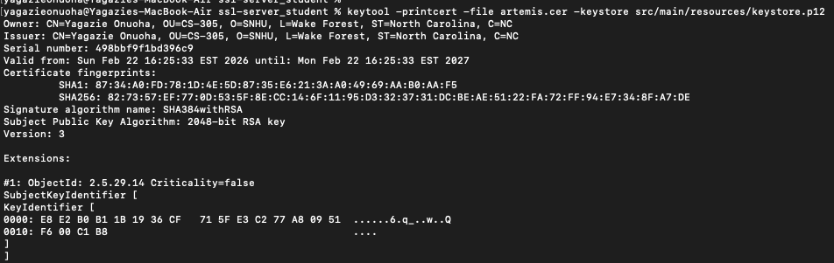

Deploy Cipher
Insert a screenshot below of the checksum verification.

Implemented a SHA-256 cryptographic hash function in Java to generate a checksum for input data. The /hash endpoint accepts a static string and outputs the SHA-256 hash, demonstrating secure data verification. A screenshot of the running endpoint is included to show functionality.
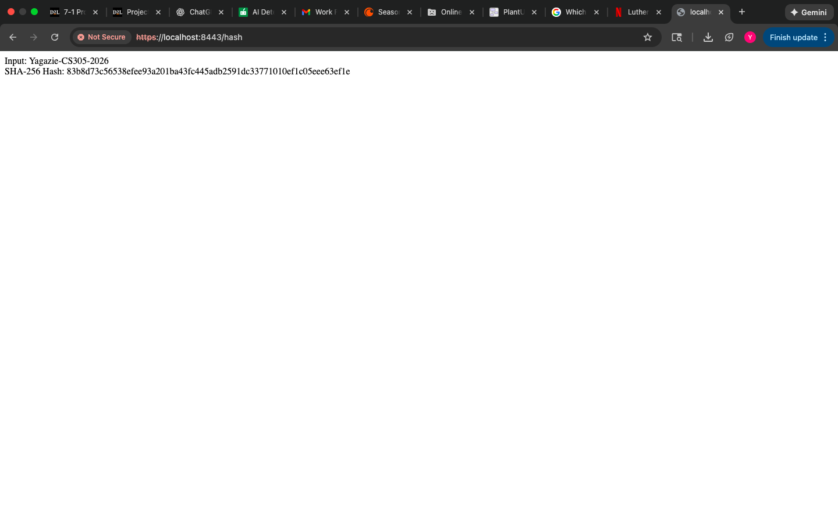

Secure Communications
Insert a screenshot below of the web browser that shows a secure webpage.
The web application is using HTTPS with a self-signed certificate. The browser may display a “Not Secure” warning because the certificate is not signed by a recognized Certificate Authority. Despite this warning, the communication is encrypted, and the certificate details confirm that HTTPS is functioning.


Secondary Testing
Insert screenshots below of the refactored code executed without errors and the dependency-check report.

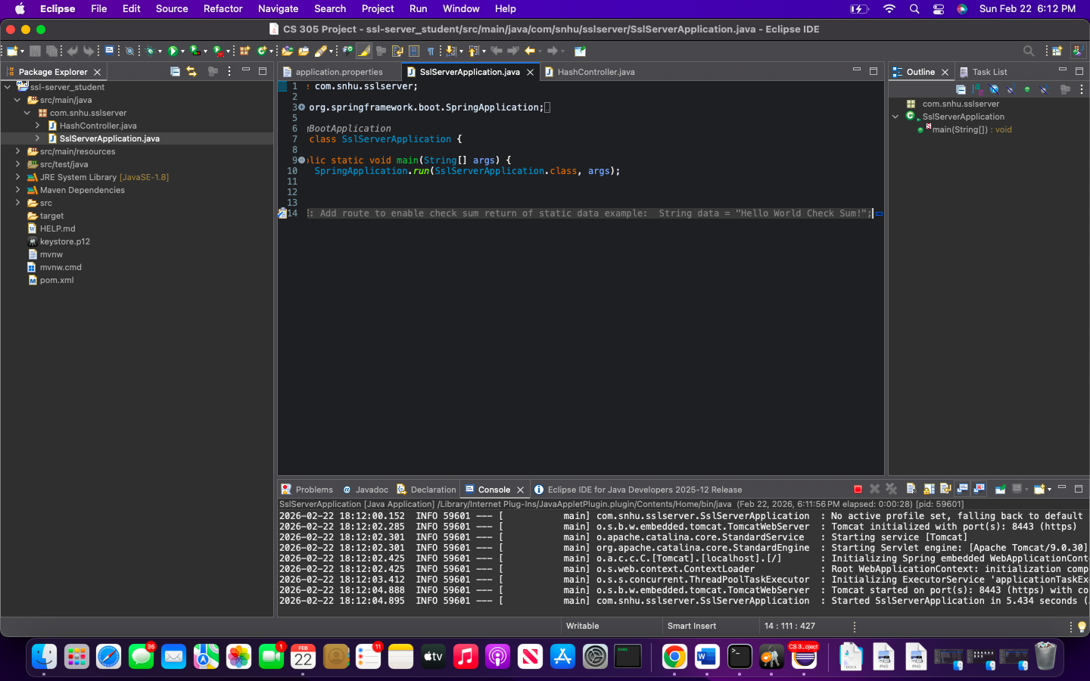

Functional Testing
Insert a screenshot below of the refactored code executed without errors.



Summary

The refactored code enhances the security of Artemis Financial’s application by adding SHA-256 checksum verification and HTTPS secure communication. The project followed a structured process:
- Added SHA-256 hashing to generate checksums for data integrity.
- Configured a PKCS12 keystore with a self-signed certificate for HTTPS.
- Verified functionality and tested for potential vulnerabilities using static analysis.
These measures improve overall application security and align with industry practices.

Industry Standard Best Practices

I followed industry-standard secure coding practices by:
- Using a strong cryptographic hash (SHA-256) for data integrity verification.
- Enabling HTTPS with a self-signed certificate to protect communications.
- Avoiding hardcoded sensitive data beyond testing.
- Running static code analysis to identify potential vulnerabilities.
Applying these practices helps mitigate known threats and improves the trustworthiness and reliability of the software.

